EX. NO: 08 Nmap to discover live hosts
DATE: 30.07.2026

AIM:
To use Nmap to discovery live hosts using ARP Scan ,ICMP scan , and TCP/UDP Ping Scan in the tryhackme platform.

TASK : 2 - SUBNETWORKS:

Send a packet with following
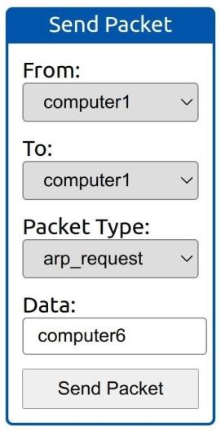

- From computer1
- To computer1 ( to indicate it is broadcast )
- Packet Type: “ ARP Request”
- Data : computer6 ( because we are asking for computer6 MAC address using ARP Request )

How many devices can see the ARP Request? Ans : 4

Did computer6 receive the ARP Request ? ( Y / N ) Ans : N Send a packet with the following:

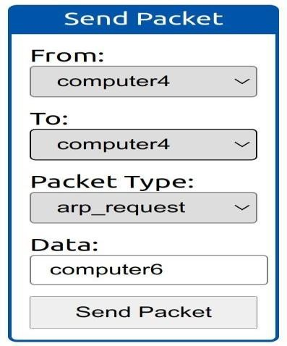
- From computer4
- To computer4 ( to indicate it is broadcast )
- Packet Type: “ ARP Request”
- Data : computer6 ( because we are asking for computer6 MAC address using ARP Request )

How many devices can asee the ARP Request ? Ans : 4

Did computer6 reply to the ARP Request ? (Y / N ) Ans : Y
TASK - 3 : Enumerating Targets
What is the first IP address Nmap would scan if you provided 10.10.12.13/29 as your target ?
Ans : 10.10.12.8
How many IP addresses will Nmap scan if you provide the following range 10.10.0-255.101-125 ?

Ans : 6400
TASK - 4 : Discovering Live Hosts Send a packet with following :
- From computer1
- To computer3
- Packeet Type : “Ping Request”

What is the type of packet that computer1 sent before the ping ?
Ans : ARP Resquest
How many computers responded to the ping request? Ans : 1 Send a packet with following:
- From computer2
- To computer5
- Packet Type: “Ping Request”

What is the name of the first device that responded to the first ARP Request? Ans : router
What is the name of the first device that responded to the second ARP Request? Computer5 Send another Ping request.Did it required new ARP Requests? ( Y / N ) Ans : N

TASK - 5 : Nmap Host Discovery Using ARP

We will be sending broadcast ARP Requests packets with the following options:

  - From computer1
  - To computer1 (to indicate it is broadcast)
  - Packet Type: “ARP Request”
  - Data: try all the possible eight devices (other than computer1) in the network: computer2, computer3, computer4, computer5, computer6, switch1, switch2, and router.

How many devices are you able to discover using ARP requests? Ans : 3

TASK - 6 : Nmap Host Discovery Using ICMP Nmap Host Discovery Using ICMP :
What is the option required to tell Nmap to use ICMP Timestamp to discover live hosts? Ans : -
PP

What is the option required to tell Nmap to use ICMP Address Mask to discover live hosts? Ans : -PM

What is the option required to tell Nmap to use ICMP Echo to discover live hosts? Ans : -PE

TASK - 7 : Nmap Host Discovery Using TCP and UDP
Which TCP ping scan does not require a privileged account? Ans : TCP SYN Ping

Which TCP ping scan requires a privileged account? Ans : TCP ACK Ping

What option do you need to add to Nmap to run a TCP SYN ping scan on the telnet port? Ans : -PS23

TASK - 8 : Using Reverse - DNS Lookup

We want Nmap to issue a reverse DNS lookup for all the possibles hosts on a subnet, hoping to get some insights from the names. What option should we add? Ans : -R

RESULT :
Nmap to discover live host usng ARP scan ,ICMP scan and TCP/UDP ping scan in the tryhackme platform.

